Chapter 17, Solution 48.

(a) For the DC component, i(t) = 20 mA. The capacitor acts like an open circuit so that
v = Ri(t) = 2x10³x20x10^{–3} = 40

For the AC component,
ω_{n} = 10n, n = 1,2

1/(jω_{n}C) = –j/(10nx100x10^{–6}) = (–j/n) kΩ

Z = 2||(–j/n) = 2(–j/n)/(2 – j/n) = –j2/(2n – j)

V = ZI = [–j2/(2n – j)]I

For n = 1, V₁ = [–j2/(2 – j)]16∠45° = 14.311∠–18.43° mV

For n = 2, V₂ = [–j2/(4 – j)]12∠–60° = 5.821∠–135.96° mV

v(t) = 40 + 0.014311cos(10t – 18.43°) + 0.005821cos(20t – 135.96°) V
(b) p = V_{DC}I_{DC} + 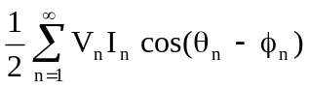

= 20x40 + 0.5x10x0.014311cos(45° + 18.43°)
+0.5x12x0.005821cos(–60° + 135.96°)

= 800.1 mW

